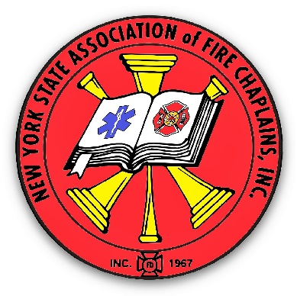
Chaplain Leon I. VanWie
Chief Chaplain
New York State Association of Fire Chaplains, Inc.
PO Box 777
111 Franklin Street
Brownville, NY 13615
(315) 771-9142 (Voice and Text)
LeonVanWie@gmail.com E-mail

20/21 Vision for Chaplains – Seeing & Serving
NEW YORK STATE ASSOCIATION OF FIRE CHAPLAINS, INC.
Annual Fire Chaplain’s Training Conference: August 15 – August 18, 2021

Dear Fire and EMS Chaplain,

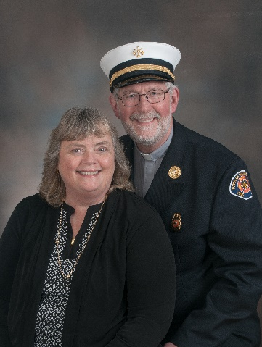
Margie and I, along with the Board of Directors of the NYSAFC, Inc. are excited to invite you to this year’s Annual Training Conference. It will be held at the Ramada Inn (21000 NYS Rte. 3, Watertown, NY 13601 – (315) 788-0700). The Ramada Inn is just off Interstate 81 at exit 45 (coming from the south, turn left and stay in the left lane, and as you might guess, coming from the north, turn right and get into the left lane – it is the first driveway on the left).

Chaplains are called upon for a variety of important tasks: Invocations/Benedictions at banquets, dedicatory prayer/blessing of apparatus, planning a Memorial Service for a firefighter, and many other important responsibilities. However, one of the most challenging tasks we are called upon to handle are tragic events with people emotionally and spiritually hurting. What do you do and say when you arrive on the scene of a fatality, with surviving loved ones crying hysterically?

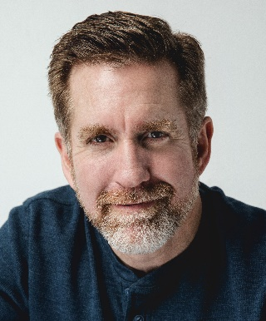
I’m pleased that Dr. Ryan N. Fraser, Ph.D., LCPT is available this year and will be our presenter/trainer. Dr. Fraser is a tenured Associate Professor of Clinical Mental Health Counseling at Freed-Hardeman University in Henderson, Tennessee. He has been teaching in the graduate counseling and undergraduate psychology programs since 2006. He teaches a wide spectrum of courses, which focus on challenging topics including crisis intervention and counseling, grief care and counseling, depression and anxiety management, and many more.

After we spend nearly seven hours of training with Dr. Fraser, we will then participate in a training where we will use the tools we have learned in role-playing situations. I’m hoping it will be a very helpful practical training that we will never have to use (but we will be prepared when the crisis arises).

It has been a challenging year for all of us and I’m so excited to offer this in-person training. The cost of this conference for Fire Chaplains is less than many of the other associations around the state, but it is not as low as I would have preferred and for that – I’m sorry.

Once you settle in to your room at the Ramada, there are plenty of choices for restaurants nearby (Red Robin, Long Horn Steak, Panera Bread, Pizza Hut, Red Lobster, Texas Roadhouse, Olive Garden, Tully’s, IHOP, Buffalo Wild Wings, Five Guys, Chipotle Mexican Grill, Chinese, Denny’s, Applebees, Cracker Barrel, Japanese Steak House, McDonald’s, Arby’s, Taco Bell, and many local nearby favorites: Fairgrounds, Pete’s, and Art’s Jug, to name just three).

Events are still being finalized for the spouses, but at present we have some time for shopping planned, a possible speaker and a special “Painting” event hosted and sponsored by Lynnette Lundy-Beck. Please check out the enclosed flyer for spouses.

The conference ends with lunch on Wednesday. If you will be leaving before lunch, please indicate that on the registration form so I will be able to get your certificate to you.

Please either complete the enclosed REGISTRATION form, or go to our website http://www.nysafc.org/home.aspx and download a Word document. The completed form needs to be returned to me. You can pay for the conference using PayPal on the website as well.

Conference Reservations must be made and submitted with the enclosed form, PREPAID in advance by check, money order or PayPal. All checks are payable to: New York State Association of Fire Chaplains, Inc.

I realize that some may still be uncomfortable gathering in-person in Watertown, but still wish to participate in the training. In an attempt to accommodate all chaplains, a person can receive a 20-25 page workbook from Dr. Fraser, view the training online and receive a certificate, at a cost of $60. While I know the in-person training will be a great learning experience, so that all can participate we are offering this as an option.

Reservations must be received by Sunday, August 1, 2021. After August 1st, please enclose a late fee of $50.00 and call me for availability.

Cancellations can be accepted until August 1st without penalty. Unfortunately, refunds after that date may not be able to be processed.

Check in time at the Ramada is 3:00 PM on Sunday, August 15th and check out time is 11:00 AM on Wednesday, August 18th. If you wish to arrive on Saturday or leave on Thursday, please indicate that on the registration form. The cost for each additional night is $90.00.

The tentative Conference Agenda (Draft A) is attached. We look forward to your attendance at this year’s conference.

If you have any specific questions or special needs, please contact me directly at the contact information on the top of page one.

Sincerely,
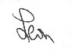
Rev. Leon VanWie, Chief Chaplain

Enc. - Registration Form, Spouses Events Planned, Agenda

